Learning logic simulator

manual

summary

The "Logic Circuit Simulator for Learning" is a simulator that allows you to create digital circuits that freely combine parts such as logic elements and switches, and measure the logical state of the created circuit using the oscilloscope function. It also has a function to display the logic status in the circuit.
Considering its use for learning purposes, it has a "teacher mode" for creating materials and a "learning mode" for learners.

In addition, since this "logic circuit simulator for learning" is written only in JavaScript, it can be installed in an environment where an HTTP (S) server is running, and it can be used in more environments. (The upload function of teaching material data requires a script execution environment on the server side, It supports multiple server-side languages (php, aspx, perl, python) so that it can flexibly support Linux and Windows servers. ）。

launch

〇 Teacher mode
In Teacher Mode, you can use all the functions of the Logic Simulator for Learning.
You can set functional restrictions in "Learning Mode" for each teaching material data.

Starting in Teacher Mode
You can launch it in one of the following ways:
Start lg cs.html as lg cs.html?mode=teacher
Start lgcs.html and open "teacher.dat"
* Teaching material data on the server cannot be opened in teacher mode. Start in teacher mode and enter the local file "(Material Name). dat".

〇 Learning mode
In "Learning Mode", each teaching material data can be used within the scope of the functions set in "Teacher Mode".

Start in "Learning Mode" (Load Teaching Material Data)
You can launch it in one of the following ways:
Start lgcs.html and open the local file "(teaching material name).dat".
- Start lgcs.html as lgcs.html ?data= (teaching material name) (when uploading teaching material data to the server's data folder)

menu

Start-up screen in "Teacher Mode"
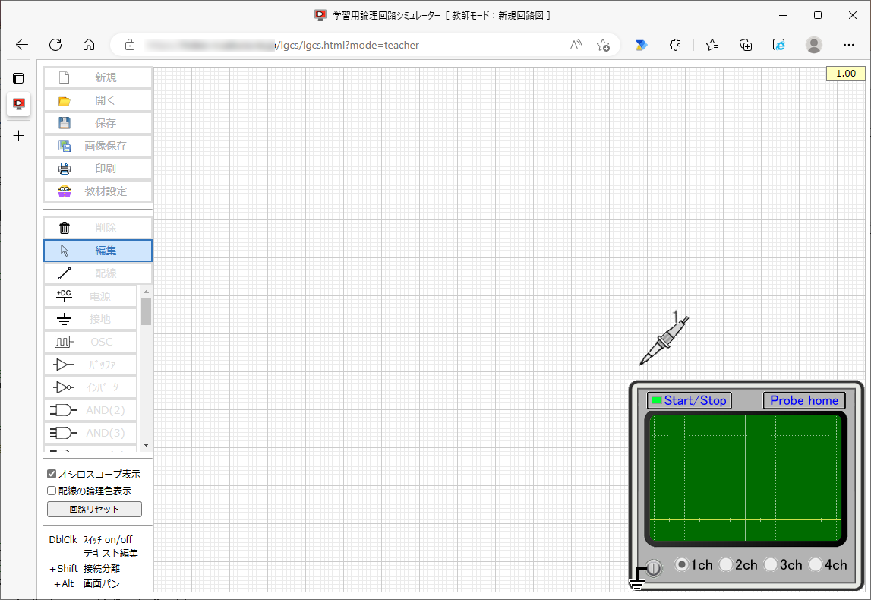

Processing Menu

Edit menu

Oscilloscope features
Parts Menu

Auxiliary Menu

〇 Processing menu
new
Erases the schematic being edited and sets it to the activated state in "Teacher Mode".

open
Open the teaching materials data file and view the schematic.
Teacher Mode opens with all features enabled, regardless of the limitations of Learning Mode.

preservation
Save the teaching material data file to a local file.
The save destination depends on the browser settings, and if a file with the same file name exists in the save destination, a branch number such as (1) will be added depending on the browser function.

Image storage
Saves the schematic displayed on the screen (including the state of the oscilloscope) to a local file in the form of a PNG image.
The save destination depends on the browser settings, and if a file with the same file name exists in the save destination, a branch number such as (1) will be added depending on the browser function.

printing
Print the schematic shown on the screen, including the state of the oscilloscope.

Teaching Materials Settings
Set the restrictions in "Learning Mode".
Here you can set the menu item to enable or disable the function in "Learning Mode".
In the schematic editing function, you can set the enable/disable for each part.
The settings here are enabled in "Learning Mode", and in "Teacher Mode", all functions are available regardless of the settings here.
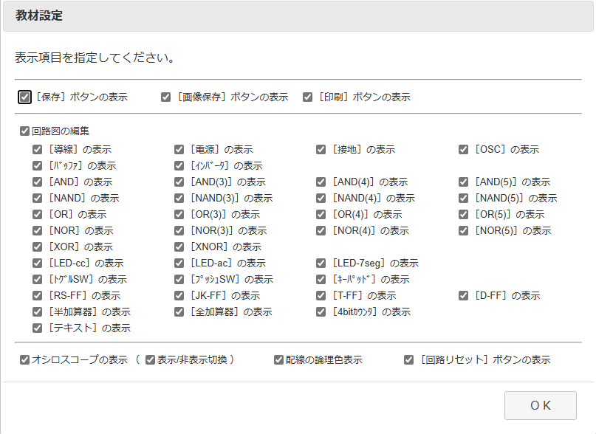

〇 Edit menu
deletion
Delete parts and wires on the schematic.
Select the [Delete] button and click on a part or wire on the schematic to delete the clicked part or wire. After deletion, the Edit button will be selected.
Youcan delete it continuously by holding down the C trl key and clicking.

edit
You can edit the position movement and connection status of parts and wires on the schematic.
You can move a part, wire, or connection point while maintaining the connection state by dragging the connection state, or you can release the connection state by dragging the part, wire, or connection point while holding down the S hift key.
You can also hold down the Alt key while dragging to pan the entire schematic.

wiring
Place new wires between the parts on the schematic. Wiring is used to electrically connect other parts together.
Select the [Wiring] button and click on the schematic By dragging from the connection point of , the wiring is placed on the schematic.
By holding down the C trl key while clicking on an existing wire, you can add a connection point and split the wire.

〇 Parts Menu
Each part in the parts menu can be placed by clicking on the drawing with the Menu button selected. After placement, you will automatically enter edit mode.
You can place them continuously by holding down the Ctrl key and clicking.

power
Let the connection circuit be the Hi level.

ground
Let the connection circuit be the Lo level.

OSC
It is a transmitter that transmits at a frequency of approximately 1 Hz. The frequency cannot be changed.

Basic Gate
 |  | 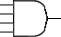 | 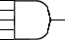
 |  | 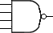 | 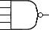
 |  | 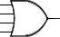 | 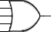
 |  | 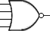 | 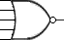
20 gates are available: buffer, inverter, 2-input AND, 3-input AND, 4-input AND, 5-input AND, 2-input NAND, 3-input NAND, 4-input NAND, 5-input NAND, 2-input OR, 3-input OR, 4-input OR, 5-input OR, 2-input NOR, 3-input NOR, 4-input NOR, 5-input NOR, XOR, XNOR.

LED
Both types of LEDs can be used: cathode common type and anode common type.

LED (7-segment indicator)
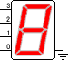
A cathode common-type 7-segment LED indicator (4-bit binary input) can be used.

switch
Two types of switches are available: toggle switches and push switches. All switches are Lo level when open and Hi level when closed.

keypad
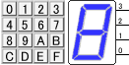
It outputs 1 6 values up to 0x00~0x0F in 4-bit binary format with positive logic.

flip-flop
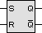 | 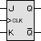 | 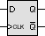 | 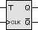
Four types of flip-flops are available: RS-FF, JK-FF, D-FF, and T-FF.

other
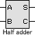 | 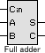 | 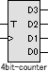
Half-adder, full adder, and 4-bit-binary counters are available.

text
Align the text. Text parts can be used to add part numbers or display explanatory text on schematics.

〇 Auxiliary menu
Viewing the Oscilloscope
You can show or hide the oscilloscope.

Logical color display of wiring
The logical value of the wiring can be displayed as Hi=red and Lo=blue.

Circuit Reset
The circuit can be reset. Use when the logic state of the circuit becomes unstable.

〇 Oscilloscope function
The oscilloscope function allows you to measure the logical state of up to four channels of part and wire connection points. You can toggle the number of channels by clicking the radio button on the oscilloscope image (default is single-channel mode).
As shown in the figure, the probe is not displayed in the OFF mode, and in the other modes, the probe is displayed as follows.
You can also click Start/Stop on the oscilloscope image to pause the waveform display, or click Probe home to open the probe to the home position ( Return to the top of the oscilloscope image.

〇 Wiring error display and processing
Connecting Outputs
When the output terminals of parts are connected by wiring, an error message is displayed in the upper right corner of the circuit screen, the wiring is displayed as a thick red line, and the screen background is light red.
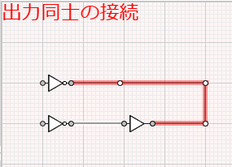

Looping wiring
If there is no problem with the electrical connection, but the wiring is looped, an error message is displayed in the upper right corner of the circuit screen, the wiring is displayed as a thick red line, and the screen background is light red.
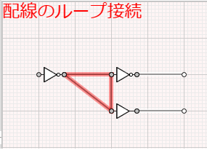

Overlapping placement of parts and wiring
If all terminals overlap or if there are wires with the same origin and end, one of the parts or wires is automatically deleted.
In the following cases, it will not be automatically deleted and an error will be displayed, so delete it manually.
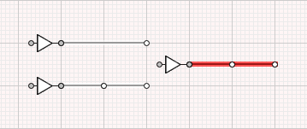
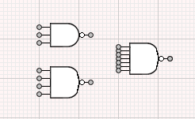

"Loop connection of wiring" error
"Connect outputs" error

〇 Reduced display function
When a large circuit diagram created on a high-resolution PC is opened on a low-resolution device such as a Chromebook, the entire screen is reduced so that the entire schematic can be displayed.
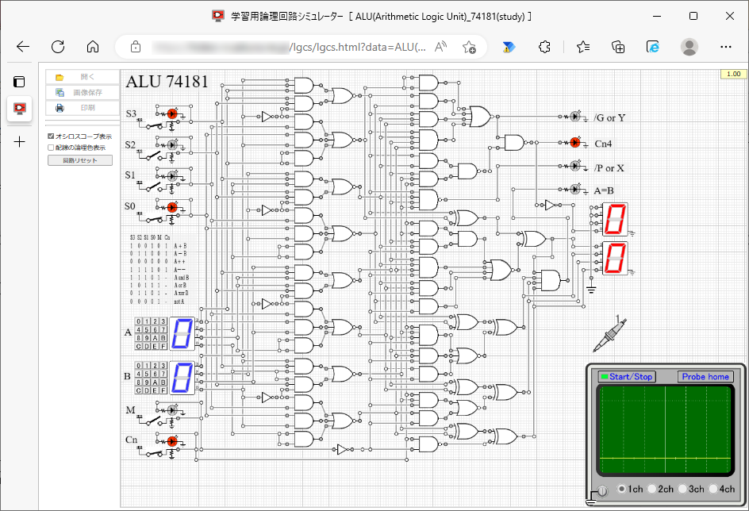

Editing Schematics

〇 Placement
Part Placement
In the Parts menu, you can place a part by selecting it and clicking on the drawing. At this time, you can hold down the Ctrl key while clicking to place multiple parts in a row.

Moving Parts
By dragging the image portion of each part, you can move the part while remaining connected. At this time, if you hold down the Shift key while dragging, you can disconnect and move only the dragged part.
However, if the parts are directly connected to each other, they cannot be moved.

wiring
With "Wiring" selected in the "Edit menu", you can place the wiring by dragging the connection point (white circle or gray ●) of the part or wiring to the starting point (after dragging, confirm the placement with the mouse-up).
By holding down the C trl key while clicking on an existing wire, you can add a connection point and split the wire.

Moving Wiring
By dragging the wires, you can move them while maintaining the connection. At this time, if you hold down the Shift key while dragging, you can disconnect the connection and move only the dragged wire.
However, wires that are directly connected to the part cannot be moved.

Moving a connection point
By dragging the connection point (white circle) between the wires, you can move the connection point while maintaining the connection. At this time, hold down the Shift key while dragging to disconnect the connection and move only the connection point.
The connection point (gray ●) of the part cannot be moved (you can break the connection with the Shift key). ）。

Removing Parts and Wires
With the [Delete] button selected, click each part or wire to delete the clicked part or wire. At this time, you can delete multiple parts and wires in a row by holding down the Ctrl key and clicking.

Panning the schematic screen
You can pan the screen by holding down the Alt key while dragging. The function to select and move a part of the screen is not implemented.

