DC circuit simulator for learning

Manual

This manual is translated from Japanese using machine translation.

This application will start in the display language according to the language setting of the browser (language setting that can be obtained with "window.navigator.language").
You can explicitly change the display language by adding "lang=ja" or "lang=en" to the parameter (eg dccs.html?lang=en).
By customizing “js/dccs-lang.js”, it is possible to display in languages other than Japanese and English.

Summary
"DC circuit simulator for learning" is a simulator that allows you to create electronic circuits that freely combine dry batteries, light bulbs, resistors, voltmeters, ammeters, and switch parts, and use the tester function to measure the synthetic resistance value of the created circuit and the current value and voltage value in the circuit.
Considering its use for learning purposes, it has a "Teacher Mode" for creating materials and a "Learning Mode" for learners.

In addition, since this "DC circuit simulator for learning" is written only in JavaScript, it can be installed in an environment where an HTTP (S) server is running, and it can be used in more environments (the upload function of teaching material data requires a script execution environment on the server side, It supports multiple server-side languages (php, aspx, perl, python) to flexibly support Linux and Windows servers. ）。

Launch
〇Teacher Mode
In "Teacher Mode" you can use all the functions of the "DC circuit simulator for learning".
You can set functional restrictions in "Learning Mode" for each teaching material data.

Starting in “Teacher Mode”
You can launch it in one of the following ways:
・Start “dccs.html” as “dccs.html?mode=teacher”
・Start “dccs.html” and open "teacher.dat".
* Teaching material data on the server cannot be opened in “Teacher Mode”. Start in “Teacher Mode” and open the local file "(Teaching material name).dat".

〇Learning Mode
In "Learning Mode", each Teaching material data can be used within the scope of the functions set in "Teacher Mode".

Start in "Learning Mode" (Load Teaching material data)
You can launch it in one of the following ways:
・Start “dccs.html” and open the local file "(Teaching material name).dat".
・Start “dccs.html” as “dccs.html?data=(Teaching material name) (when uploading Teaching material data to the server's data folder.)

Menu
Start-up screen in "Teacher Mode"
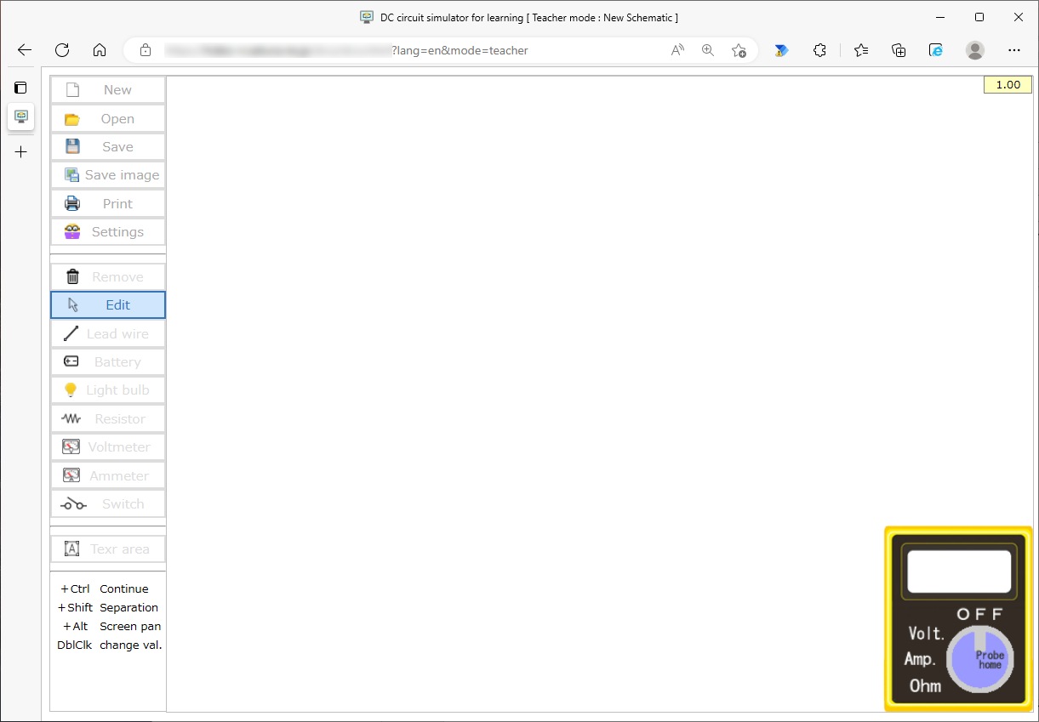

Processing Menu

Parts Menu

Tester function

〇Processing menu
New
Erases the schematic being edited and sets it to the activated state in "Teacher Mode".

Open
Open the Teaching materials data file and view the schematic.
Regardless of the limitations of "Learning Mode", it opens with all features enabled.

Save
Save the Teaching material data file to a local file.
The save destination depends on the browser settings, and if a file with the same file name exists in the save destination, a branch number such as (1) will be added depending on the browser function.

Save image
Save the schematic displayed on the screen (including the tester state) to a local file in the form of a PNG image.
The save destination depends on the browser settings, and if a file with the same file name exists in the save destination, a branch number such as (1) will be added depending on the browser function.

Print
Print the schematic displayed on the screen (including the status of the tester).
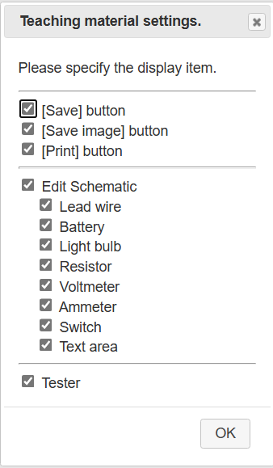
Settings (Teaching materials settings)
Set the restrictions in "Learning Mode".
Here you can set the menu item to enable or disable the function in "Learning Mode".
In the schematic editing function, you can set the enable/disable for each part.
The settings here are enabled in "Learning Mode", and in "Teacher Mode", all functions are available regardless of the settings here.

〇Parts Menu
Remove
Remove a part on the schematic.
Select the [Remove] button and click a part on the schematic to remove the clicked part. After deleting the part, the [Edit] button will be selected.
You can remove parts continuously by holding down the Ctrl key and clicking on them.

Edit
You can edit the position and connection status of parts on the schematic.
You can move a part or connection point while maintaining the connection state, or you can break the connection by dragging a part or connection point while holding down the Shift key.
You can also hold down the Alt key while dragging to pan the entire schematic.

Lead wire
Place the Lead wire parts on the schematic. Lead wire parts are used to electrically connect other parts to each other.
Select the [Lead wire] button and click on the schematic to place the Lead wire parts on the schematic. After placing the [Lead wire] part, the [Edit] button is selected.
By holding down the Ctrl key and clicking, you can place them continuously.

Battery
Place the battery parts on the schematic. The electromotive force and internal resistance of the Battery parts can be set (initial value is 1.5V electromotive force and 0.1Ω internal resistance) in "Teacher Mode", and the electromotive force can be changed by setting in "Learning Mode".
Battery parts can be placed contiguously in the same way as lead wire components.

Light bulb
Place the Light bulb parts on the schematic. The internal resistance of the Light bulb parts can be set (initial value is 5 Ω) in "Teacher Mode" and cannot be changed in "Learning Mode".
For Light bulb parts, power consumption (if less than 5W. At 5W or more, the brightness is the same. The brightness changes accordingly.
Light bulb parts can be placed contiguously in the same way as lead wire components.

Resistor
Place the Resistor parts on the schematic. The resistance value of the Resistor part can be set (initial value is 100 Ω) in "Teacher Mode" and can be changed by setting in "Learning Mode".
Resistive parts can be placed contiguously in the same way as lead wire components.

Voltmeter
Place the Voltmeter parts on the schematic. The internal resistance of the Voltmeter parts can be set (initial value is 100000 Ω) in "Teacher Mode" and cannot be changed in "Learning Mode".
The Voltmeter parts displays the potential difference between the connection terminals in absolute terms regardless of the direction of the connection.
Voltmeter parts can can be placed contiguously in the same way as lead wire components.

Ammeter
Place the Ammeter parts on the schematic. The internal resistance of the Ammeter parts can be set (initial value is 0.001 Ω) in "Teacher Mode" and cannot be changed in "Learning Mode".
The Ammeter parts displays the current flowing through the connection part as an absolute value, regardless of the direction of the connection.
Ammeter parts can be placed contiguously in the same way as lead wire components.

Switch
Place the Switch parts on the schematic. Switch parts specify the opening and closing of circuits.
Switch parts can be placed contiguously in the same way as lead wire components.

Text area
Place the Text area parts on the schematic. Text area parts can be used to add parts numbers or display explanatory text on schematics.
Text area parts can be placed contiguously in the same way as lead wire components.

〇Tester function
The tester function has four modes: OFF mode, Voltage mode, Current mode, and Resistance mode. You can switch modes by clicking each mode character on the tester image (initial state is OFF mode).
As shown in the figure, the probe is not displayed in the OFF mode, and in the other modes, the probe is displayed as follows.
You can also click on the dial portion of the tester image to return the probe to the home position (top of the tester image).
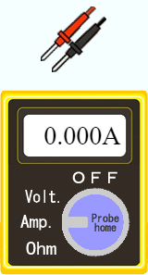
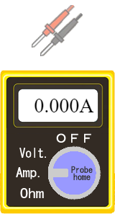
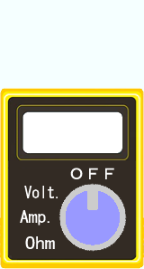
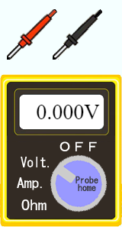
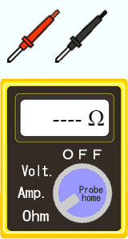

Resistance Mode
Current Mode
Voltage mode
OFF mode

In Current mode, if the circuit is open and no current is flowing, the probe is disabled.

Voltage mode
By placing two probes, red and black, at the connection points of the parts, the potential difference between the two connection points is displayed. In this case, unlike the Voltmeter parts, the potential difference is displayed ±, depending on the placement position of the probe.
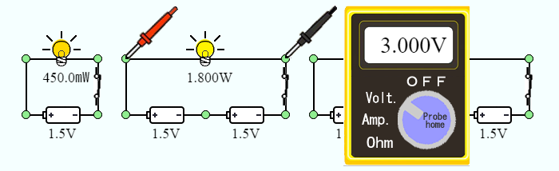

Current mode
By placing a single probe in a pair of red and black in the wiring part of the part, the current value flowing through it is displayed. In this case, as with the Ammeter parts, the current value is displayed in absolute terms.
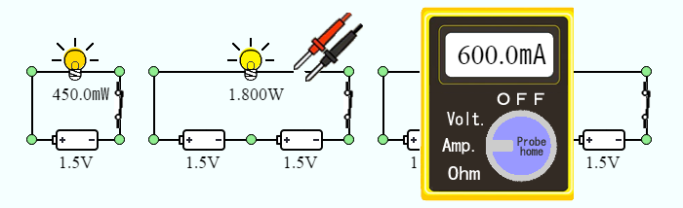

Resistance mode
By placing two probes, one red and one black, at the connection points of the parts, the resistance value between the two connection points is displayed.
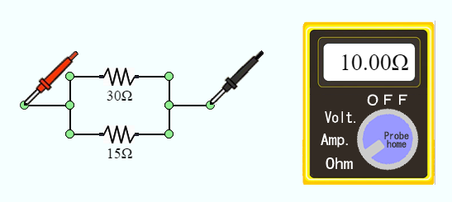

Editing Schematics
〇Placement
Placement of parts
By dragging the image portion of each part, you can move the parts while remaining connected.
At this time, if you hold down the Shift key while dragging, you can disconnect and move only the dragged parts.

Move a connection points
By dragging the connection points (green circles) between parts, you can move the connection points while maintaining the connection.
At this time, if you hold down the Shift key while dragging, you can disconnect the last connected parts and move the terminal part of that parts.

Remove a Part
With the [Remove] button selected; you can remove the clicked part by clicking the image part of each part.
At this time, you can delete multiple parts in a row by holding down the Ctrl key and clicking.

Panning the schematic screen
You can pan the screen by holding down the Alt key while dragging. The function to select and move a part of the screen is not implemented.

〇Change attribute values (component constants, etc.)
By double-clicking the image or text part of each part, you can change the attribute value. The attribute values that you can change depend on the type of part.
You can also set the items that can be changed in "Learning Mode".
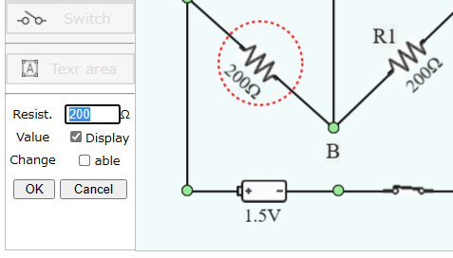

"Value" sets whether or not to display values such as resistance and current values in "Learning Mode", and "Change" sets whether or not values such as resistance values can be changed in "Learning Mode".

The modifiable attribute values for each parts are:
 | Electromotive force | Resistance | Internal resistance | Open/close state | Functional restrictions in Student Mode
 |  |  |  |  | Value display | Value change | Text editing | Resizing
Lead wire
Battery | 〇 |  | 〇 |  | 〇 | 〇
Light bulb |  |  | 〇 |  | 〇
Resistor |  | 〇 |  |  | 〇 | 〇
Voltmeter |  |  | 〇 |  | 〇
Ammeter |  |  | 〇 |  | 〇
Switch |  |  |  | 〇
Text |  |  |  |  |  |  | 〇 | 〇
- Internal resistance is always unchangeable in "Learning Mode"
- The value of the Light bulb parts is the power consumption.

